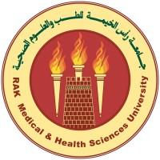
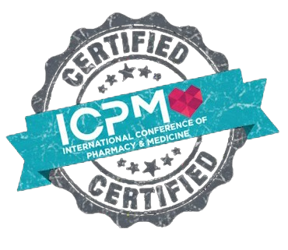

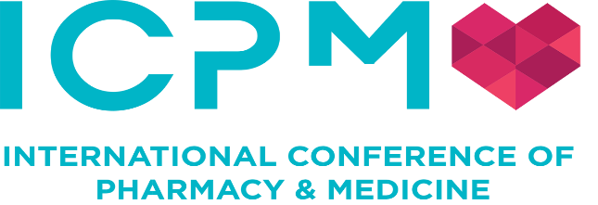

Certificate of Participation

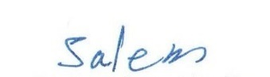
This Certificate has been awarded to

Muna Musa Gholam Alla Khalifa

For successful participation and attendance at “ICPM 2026”

the 14th International Conference of Pharmacy and Medicine (ICPM)

Held on 20th –22nd January 2026

Venue: Sharjah Research Technology and Innovation Park UAE
This Program has been awarded with total of 21 CPD Credits
Accreditation Code EHS/CPD/26/068
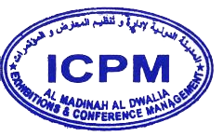

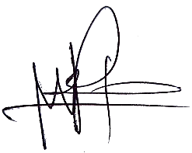
Dr. Muneer Rayan
ICPM

Prof. Omer Eladil Abdalla Hamid
RAKMHSU

Certificate Ref No. 25012301804

